**TOY STORY LESSER KNOWN ANIMATION TECHNIQUE**

TOY STORY was premiered more than 20 years from today and became one of the hit trilogies in the history of the animation world.

It was one the first computer animated feature length film.

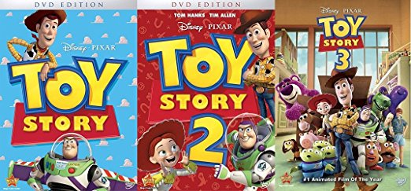

Pixar animation studios shot to the forefront in the animation world due to the high standards of innovation and creativity that the film emanated.

Even though the movie and the complete set of sequels are a classic when the Toy Story was to be made back in the 1995 it was a huge risk for Walt Disney Studios.

Walt Disney Studios put their belief on the story of a newbie at that point John Lasseter.

However today we know how the little movie based on his story about talking toys when you are not looking, fared in the world of animation.

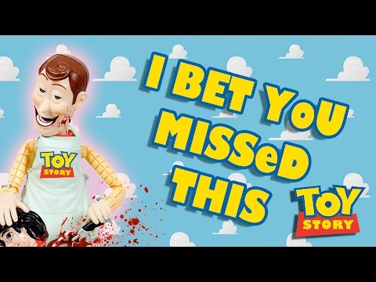

The movie has an everlasting effect on kids and adults together. Standing today you can never imagine ‘Woody’ to be mean or sarcastic, imagining Buzz Lightyear without his constant purple and lime green space suit is also another no never.

There are various facts about the animated movie trilogy that is unknown to the common populace.

**This article speaks about some of those less known facts about the animation techniques, the characters and a lot more.**

* Tom Hanks’s brother Jim gave voice to the character of Woody when he himself was busy.
* Pixar didn’t want Toy Story to be a fairy tale and tried to inculcate in the film the characters that had flaws in them so as to make the characters more interesting.
* There was a lot of problem with the script writing as the writers that the movie development began with included a lot of human characters in the movie not concentrating or grasping the fact that the movie was about toys.
* The problem was later sorted when a talented writer named Joss Wedon came on board.
* At the beginning the movie was titled as ‘You are a Toy’ the name Toy Story came in much later and was a perfect fit.
* Buzz Lightyear was originally named Tempest and his spacesuit was the colour red to begin with.

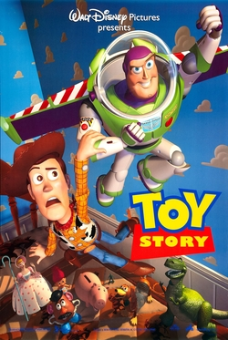

* In order to understand how their characters would actually move when they came to life after being toys the animators became toy soldiers themselves for days by nailing their shoes to wooden planks to understand the movement of the characters.
* The sales of etch a sketch was increased by leaps and bounds after the toy was shown in the movie.
* This caused the turnover of the company to be increased many fold making the company come out of bankruptcy.

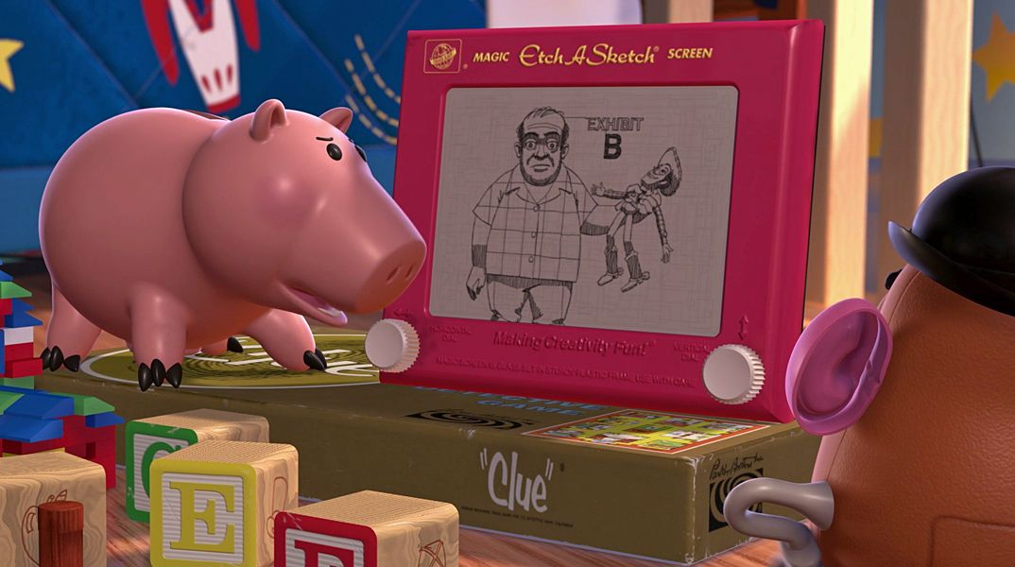

* Joss Weldon created the cute character of Rex the dinosaurs which went on to become one of the most loved characters of the movie.
* Disney originally wanted the movie to be a musical but the director did not approve of the idea.
* He rejected all the six or seven something songs which were suggested by the company for inclusion in the movie.

When the movie was still in its developmental stage nobody could even imagine the immense success that it would be getting not even the two teams Pixar and Disney which were working behind it.

When the movie was finally made looking at the sheer brilliance of the technology employed, the inspired casting alongside the story that was behind the movie it was very clear that the movie was about to hit a nerve and create quite a stir worldwide.

Pixar was initially owned by the Apple Company and almost after nine years of Toy Story’s release Disney acquired Pixar and created various computer animated feature films like it.

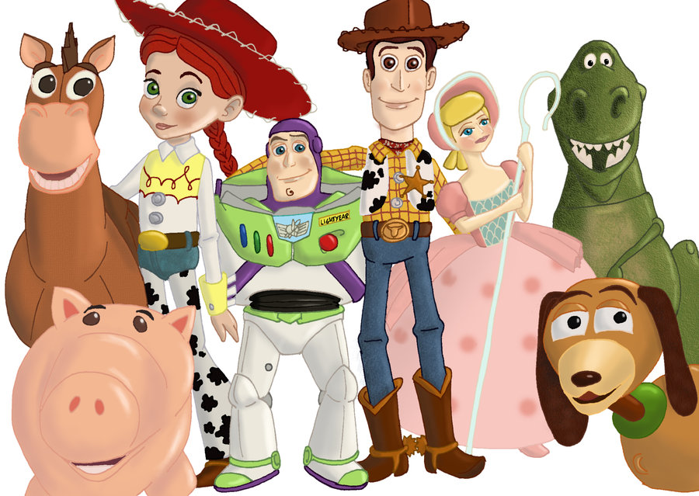

**The movie was not only the first ever computer animated feature film but also has a lot of other changes in the world of animated films.**

1. Changed the technique used for creation of animated films.
2. It looked completely different from the predecessors of in the animated film industry.
3. The movie was the first of its kind in which each of the characters, scenes and sets could be stored in computers, so that the animators didn’t need to draw the same thing again and again.
4. The digitally stored data from the first film made it possible for its usage in the sequels like in Toy Story 2, creation of products like toys, used in various TV shows and also included efficiently in CD rom games.
5. The complete economics of the animated world changed with this labor free creation of the film. It not only saved time but also saved a lot of money and other resources.
6. The Toy story was one of the highest grossing film of 1995 and led to creation of many other lucrative animation films.
7. The Toy Story and the sheer brilliance of the animation techniques used along with the huge earnings that the company received was in a way the precursor of animated movies being made on a large scale.
8. It paved the way for securing a place at the Oscars for animated movies. The movie won a special Oscar earned by their co-writer and director John Lasseter in 1966, for the creation of a first ever feature length computer animated film due to the development and usage of inspired application of techniques.
9. It was one of the first animated movie to be nominated for Best Original Screenplay. Its sequel Toy Story 3 even bagged the Best Picture award. A category for Best Animated Feature was added at the Oscars keeping in mind the brilliance of Toy Story.
10. Extremely successful stars started showing interest in given voice to animated characters after the success of Toy Story voiced by Tom Hanks and Tim Allen.
11. The creation, filming and successful release of Toy Story removed the stigma of the popular belief that animated movies were only musicals.
12. There were no musical numbers in the film that would draw excessive attention and take the focus away from the real plot of the movie. Thus it made Toy Story extremely different from the other animated movies before it.

And the story continues……………..

