**Mobiles Game Overpowered Computer Gaming**

Gaming has been the most affordable form of entertainment for kids and adults all over the world.

There are various game enthusiasts and a lot of gaming tournaments are organized worldwide all year round.

The most common and oldest medium of playing games has been the computers.

However with the advent of various new technologies and the need to play games while on the go has led to the development of various mobile games as well.

The high tech smartphones have various features to entertain its owner.

Among these features are applications to watch videos, listen to music and last but never the least play games.

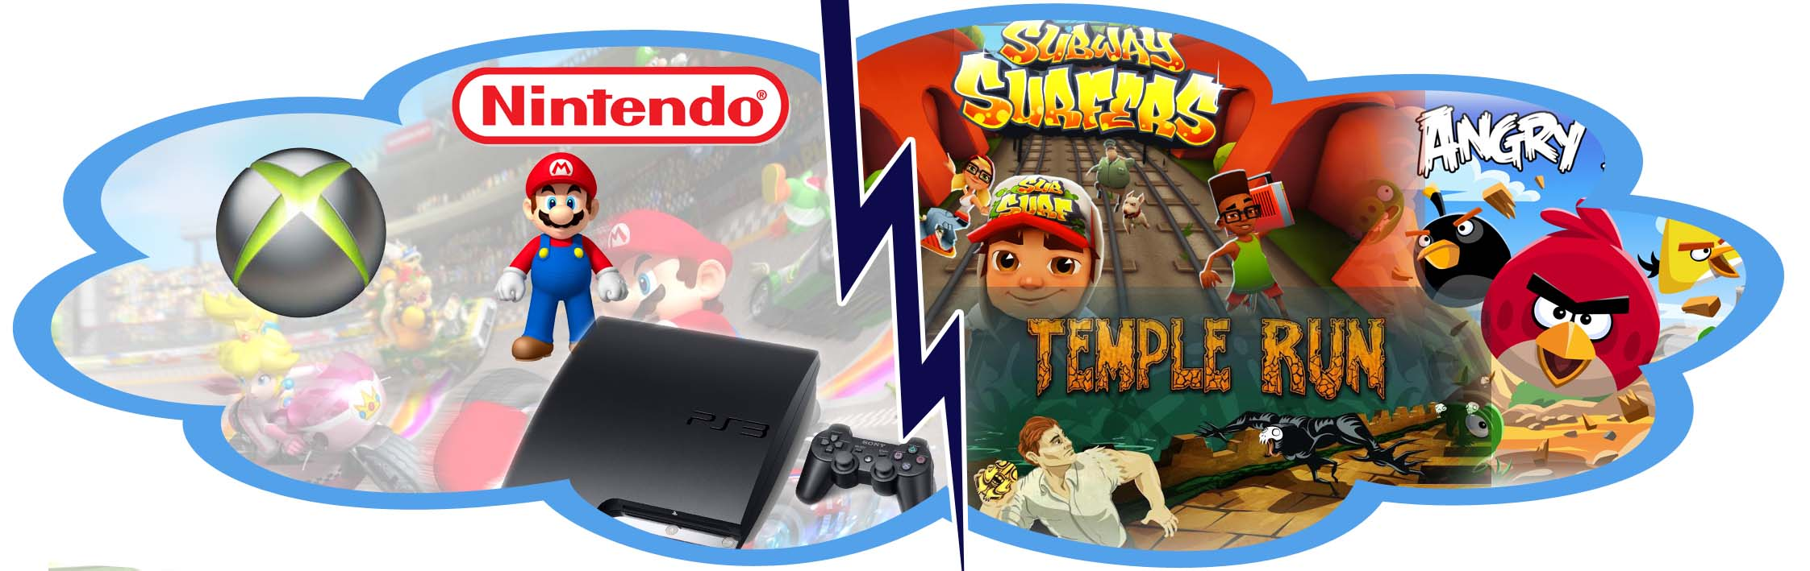

In the last few decades of the cell phone culture there has been a lot of developments in user interfaces.

Java games are in rage for quite some time and the mobile phones are nowadays coming with the games preloaded.

The mobile games are extremely rich in graphics and animation and are highly alluring to people of all ages.

Thus the mobile phones have rose to the highest pedestal in the gaming medium world due to advances in Information Technology.

In the world of continuous movement and buzz very few people have the time to spare by sitting at a gaming café or at their own computer to play games.

Thus the use of computers for gaming has dwindled down rapidly over the years.

Mobile games are the best mode of entertainment when you are bored while travelling, waiting for someone, standing in a queue, at a long and unimportant lecture or may be even while at an invitation you were dragged to by your parents.

They are the best mode of entertainment and your personal savior in the pocket.

When the mobile gaming world is looked into and researched it is easy to notice that in comparison to the games from other platforms the games developed using Java are getting the most popularity.

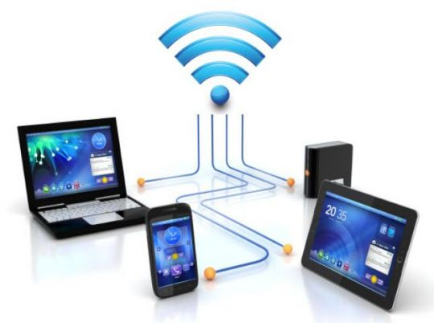

The primary reason for them rising to fame is the innovation and challenges that they put forward.

They provide for a great source of entertainment and help you with situations you know is going to take a lot of time.

Unlike computer games where getting your hand on your copy of a game is going to cost you a lot of money, in case of the mobile games there is a huge array of free games that you can download from the internet.

If you are not satisfied with the inbuilt games of your cell phone a new and addictive game is just a few taps away.

Computer games and video games were very popular at one point of time when the gaming world had just made its debut in the entertainment scene.

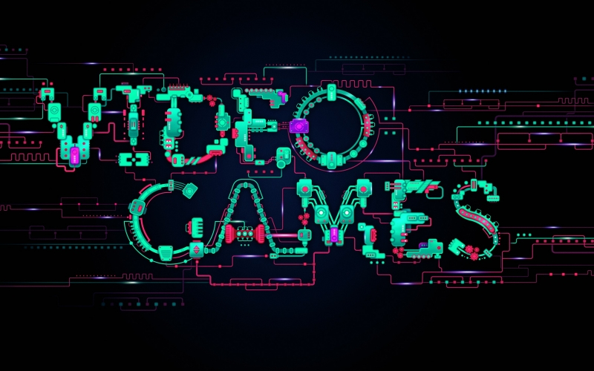

They were a good way of affordable entertainment while you took a break from the monotony of work and studying.

They helped in enhancing your attention span as you learnt how to concentrate in order to win the match and clear the levels.

However it is hard to find a span of free time to idle at home and spend hours in front of your computer to be able to play games.

Continuous pressure at work or your homework’s from the institute make it an ordeal to find a moments respite.

Since everyone nowadays has an internet connection in their mobile phones the best way to entertain yourself is by using your phone as a medium to play games.

Searching for games in your mobile is a very easy task.

Mobile even has Bluetooth and infrared these days and thus accessing games using these features is also possible.

Most mobile games are downloading via the radio network of the operators that your phone uses and because of the colored screen and HD quality pictures they are highly favored by gamers.

There many ways of getting even the paid games for free in the mobile interface.

Various computer games have even launched mobile versions in order to prevent their market from dying.

The most noticeable among these computer turned mobile games are FIFA, Counter Strike and others.

It has been found that the mobile version of these games have gained greater popularity than their PC versions.

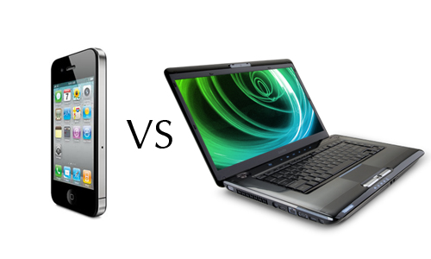

Mobile game development today has become a multibillion dollar industry.

The game developers around the globe are constantly trying to crack their brains to bring to the large.

Populace of gamers a new game every day with improved gaming experience and graphics.

The mobile gaming world has come a long way from the snake game days and today they are giving the PC games a run for their stardom.

There have been a lot of trends that has been found to go out and come into the mobile gaming business.

Some of the most noticeable trends that have made the choice of computers as gaming medium even more alien have been listed below.

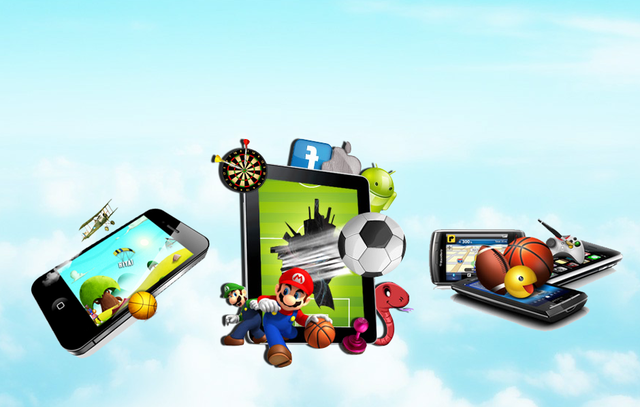

**Trends in Mobile Game Development**



* The two most popular gaming platforms today in the mobile scene are java and the iPhone app store.
* Java had been the go to platform for gamers for a very long time but the arrival of the iPhones in the market has given Java based developers a lot of competition.
* There are a wide array of multiplayer games available in the mobile gaming scene. Chess and poker being the most common of the lot.
* Playing these games in your own personal network and competing with friends makes the enjoyment double.
* The mobile gaming applications are not just for entertainment.
* They are also a way of advertisements and promotional services to showcase their merchandise.
* Over the years they have become an integral part of the games.
* Playing the games and shopping for favourite merchandise has become a one pact deal.
* There various portals that have emerged today which sell games and it have become another popular trend in the mobile gaming market.
* This has given gamers the opportunity to access a huge number of games online.
* The games are priced cheap so that they are able to reach the huge mass of people all over the globe.

So we can very well say mobiles as the medium for gaming has killed the market for computer gaming to a major extent over the years.